A2 Filmkiértékelő lámpa
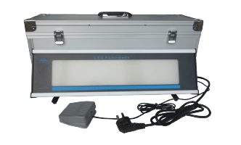
TRANSPORT CASE AND PEDAL INCLUDED

Features:

A. Armed with the most reliable high power LED, make this film viewer excellent!
B. Deluxe and attractive Aluminum alloy outer covering
C. LED operating life is longer than 50000 hours.
D. Powerful cool off fan is used, Sustains 10 hours of continuous working.
Operation Manual:
1. Plug in the foot pedal,
2. Turn the power on, brightness is at the lowest point;
3. There are two operating models: with the foot pedal switch model or without model. There is a Dip switch on the right side of the viewer. It will automatically set on the With foot pedal switch model when it is on and in this model you can adjust the dimmer by pressing the foot pedal switch and turning the knob (the preset brightness is 90000Lux) clockwise brightness up and anti-clockwise brightness down; Press the knob once,will shift to thewithoutmodel, you can adjust the dimmer by turning the knob simply.
4. Check the cool-off fan frequently and stop working when it is out of control!!!
Technical Parameters:
Maximum Luminance: 110000cd/m2
Uniformity: 0.98
Diffusion Factor: 0.95
Maximum Reading Density: 4.1H/D
Window Size: 220 x 68mm
Dimension: 370 x 110 x 65mm
Power: 110~240V
Consumption: 68w
Weight: 9 lbs

A8 Filmkiértékelő lámpa
TRANSPORT CASE AND PEDAL INCLUDED.

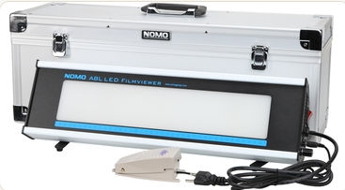

Features:
A. Armed with the most reliable high power LED, make this film viewer excellent!
B. Deluxe and attractive Aluminum alloy outer covering
C. LED operating life is longer than 50000 hours.
D. Powerful cool off fan is used, Sustains 10 hours of continuous working.

Operation manual:
1. Plug in the foot pedal,
2. Turn the power on, brightness is at the lowest point;
3. There are two operating models: with the foot pedal switch model or without model. There is a Dip switch on the right side of the viewer. It will automatically set on the With foot pedal switch model when it is on and in this model you can adjust the dimmer by pressing the foot pedal switch and turning the knob (the preset brightness is 90000Lux) clockwise brightness up and anti-clockwise brightness down; Press the knob once, will shift to the without model, you can adjust the dimmer by turning the knob simply.
4. Check the cool-off fan frequently and stop working when it is out of control!!!

Technical Parameters:
Maximum Luminance: 110000cd/m2
Uniformity: 0.98
Diffusion Factor: 0.95
Maximum Reading Density: 4.1H/D
Window Size: 400 x 80mm
Dimension: 495 x 150 x 100mm
Power: 110~240V
Consumption: 130w
Weight: 13 lbs

